# LAB ASSIGNMENT – 4

1.Print all alphabets in upper case and in lower case.

for i in range(65,91,1):

print(chr(i),end="") print() for i in range(97,123,1): print(chr(i),end="")

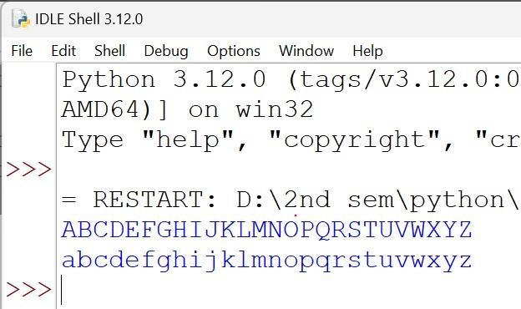

2.Print a multiplication table of a given number.

n=5 for i in

range(1,11,1):

print(n,"*",i,"=",n*i)

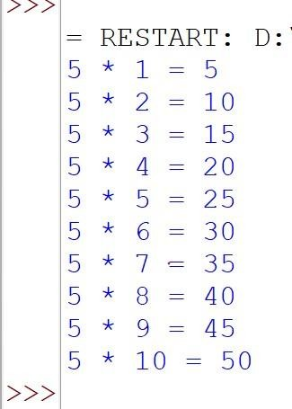

3. Count no. of alphabets and no. of digits in any given string. s="sdbhxqhjey723eyi7" d=0

a=0 for i in s: if

i.isdigit(): d+=1 if i.isalpha():

a+=1 print("Digits=",d) print("Alphabets=",a

)

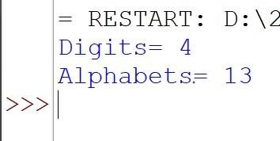

4.

Check whether a given number is prime, is perfect, is Armstrong, is palindrome, is automorphic.

n=int(input("Enter no: ")) #for prime no. for i in range(2,n,1): if(n%i==0): print("Not a prime no.") break else: print("Prime no.") break

#for perfect no. p=0 for i in range(1,n,1): if (n%i==0):

p+=i if (p==n):

print("It is a perfect no.")

else:

print("It is not a perfect no.") #for

armstrong no. '''a=0 b=n while n>0: m=n%10 a+=m*m*m

n//=10

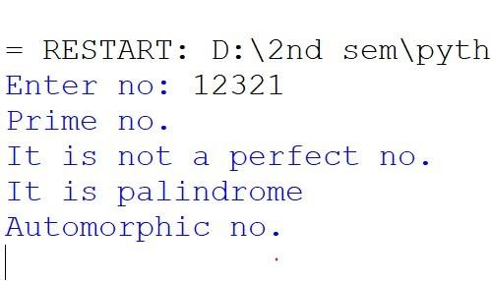

Generate all Pythagorean Triplets with side length <= 30.

for i in range(1,31,1): for j in range(1,31,1): for k in range(1,31,1): if((i*i)+(j*j)==(k*k)):

print(i,j,k)

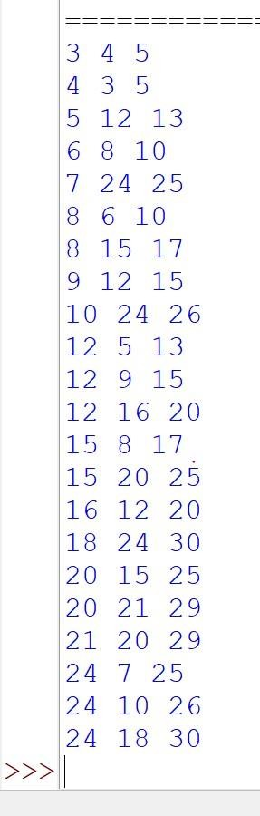

print whole day clock

print("12 o'clock noon") for i in range(1,12,1):

print(i," P.M") print("12 o'clock midnight") for i in range(1,12,1): print(i,"

A.M")

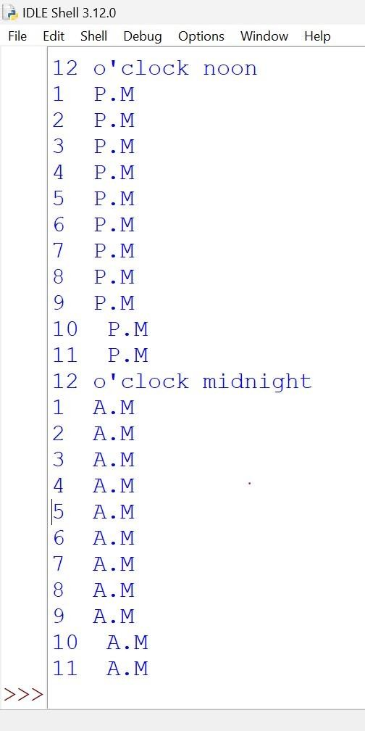

Print factorial of a given number.

no=int(input("Enter no.: "))

fact=1 for i in range(1,no,1): fact*=i print("Factorial = ",fact)

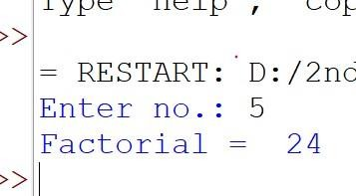

8. Print N natural nos. in reverse.

n=int(input("Enter nos. in fibonacci series: "))

n1=0 n2=1 nth=0 print("0 + 1 + ",end="") while n>0: nth=n1+n2 n1=n2 n2=nth n-=1 print(nth,"+ ",end="")

